read this…..

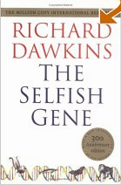
Richard Dawkins The Selfish Gene

We (and all living things) are here just to ensure the survival of our genes. Has to be read
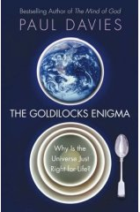
Paul Davies The Goldilocks Enigma

A challenge. Explains how the laws of physics could have resulted in someone explaining how the laws of physics could……
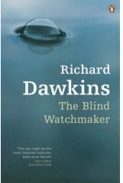
Richard Dawkins The Blind Watchmaker

Evolution: random and pointless? Darwin re-defined
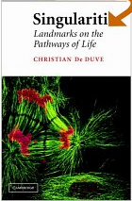
Christian De Duve Singularities: Landmarks on the Pathways of Life

What factors really define life? Hard work, but if you want to understand energy and life, worth the effort
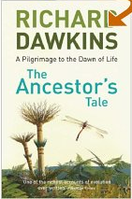

Richard Dawkins The Ancestor’s Tale

What ever you may think of his attacks on religion, this is one of the best biology books written. Brilliant description of the diversity of life. Answers those questions you think of when you’re reading the text book.
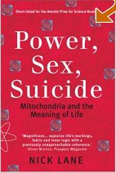
Nick Lane Power, Sex, Suicide. Mitochondria and the meaning of life
Without mitochondria, we’d still be the size of a bacterium. Convincing argument. Explains a great deal and gives some tantalizing glimpses into the future
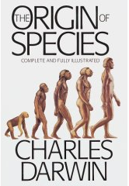

Charles Darwin The Origin of Species

He started all this. Read what all the fuss is about
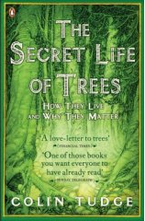

Colin Tudge The Secret Life of Trees

Just a great read. You’ll never look at a tree the same way again
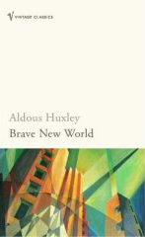

Aldous Huxley Brave New World

If you thought that using science to create a perfect world was a new idea, think again
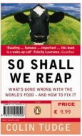

Colin Tudge So Shall We Reap

Can science solve the world’s food problems?
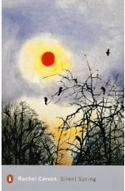

Rachel Carson Silent Spring

The birth of the eco-movement. An historical landmark that changed our view of the relationship between humankind and the environment
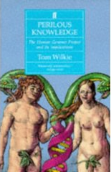

Tom Wilkie Perilous Knowledge

Written long before the Human Genome Project was complete. Tackles the ethical issues from a journalists view.
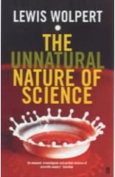
Lewis Wolpert The Unnatural Nature of Science

Science doesn’t work the way most people think it does. Common sense won’t get you far. Makes you think.
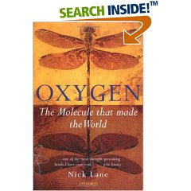
Nick Lane Oxygen. The Molecule that made the World

Without oxygen, there’d be no big plants or animals; no sex and no death. Fantastic journey through the history of the Earth and evolution.
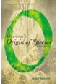
Janet Brown Darwin’s Origin of Species. A Biography

Puts the great book in its historical context. Explains why it was so revolutionary and is still such a powerful influence today.
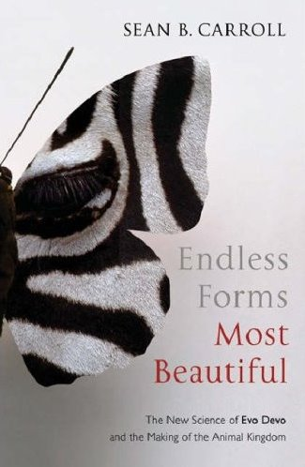
Sean B Carroll Endless Forms Most Beautiful

How did there get to be so many different animals? Why are they put together the same way? The history of evolutionary development. Very satisfying.
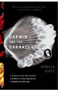
Rebecca Stott Darwin and the Barnacle

The theory of evolution started with a South American barnacle. The story of how an obsessive classifier eventually changed how we think about creation (and nearly killed himself in the process)

